Anti-Money Laundering
Supervisory Report 2021
November 2021

Contents

Foreword from Lorna Jack, CEO

1. Context to this report
2. Our AML supervisory work
AML team - structure and objectives
The AML Certificate and our risk-based approach to supervisory assurance
The Scottish legal profession – inherent risks and risk profile
AML assurance
- High risk reviews
- Medium risk reviews
- Assurance statistics
- Assurance outcomes
- Assurance – general observations
3. AML training, competency and continuous improvement
4. Participation in national AML supervisory forums
5. Reporting breaches and concerns
6. Guiding the profession
7. Moving forward

Foreword from Law Society of Scotland CEO, Lorna Jack
The Law Society of Scotland remains resolutely committed to effective Anti-Money Laundering (AML) supervision – I am exceptionally proud of the work we do to achieve this.
As the professional body for Scottish solicitors, we couldn’t be more alive to the threat posed to the profession and the public they serve from criminal activity, money laundering and terrorist financing.
I fully support the work of our AML specialists - our commitment to driving the proceeds of crime out of the legal profession is reflected in the variety of work they undertake to both inform and supervise our members.
Taking a risk-based approach to this work allows us to be robust, fair and responsible - balancing the commercial realities and the environment in which the legal profession operates with our overarching legal responsibility to ensure our members are complying with their AML obligations.
As described in this report, we employ a range of tools to assess the AML risks inherent in legal practice, the client base and the nature of work carried out. We also review the controls our members implement to mitigate these risks in light of their responsibilities under the Money Laundering Regulations.
These tools include thematic reviews, full-firm AML compliance inspections, single matter reviews and our pioneering approach to risk profiling through our annual AML certificate. This combined approach ensures that we not only supervise effectively, but also helps us to develop and deliver more focused and relevant information and training events which in turn supports firms in complying with their obligations.
We played a leading role in the recent development of revised AML guidance for the legal profession, and we actively participate in UK wide groups which bring together all professional body AML supervisors, to share best practices and information. We have recently chaired both the Legal Sector Affinity Group (LSAG) and Legal Sector Intelligence Sharing Expert Working Group (ISEWG) and can’t overstate the importance of the relationships we have built with AML colleagues across locations and sectors.
We view this report as an important step in driving awareness and transparency regarding the breadth and depth of work we do in this space and demonstrating our commitment to stamping out criminal activities in the interests of the legal profession and society as a whole.

Lorna Jack (CEO)

1. Context to this report
The Money Laundering, Terrorist Financing and Transfer of Funds (Information on the Payer) Regulations 2017 (MLRs) set administrative requirements for the anti-money laundering regime within the regulated sector.
Regulation 12 states that the regulations apply to 'independent legal professionals', that is:
“a firm or sole practitioner who by way of business provides legal or notarial services to other persons, when participating in financial or real property transactions concerning—
(a) the buying and selling of real property or business entities;
(b) the managing of client money, securities or other assets;
(c) the opening or management of bank, savings or securities accounts;
(d) the organisation of contributions necessary for the creation, operation or management of companies; or
(e) the creation, operation or management of trusts, companies, foundations or similar structures”
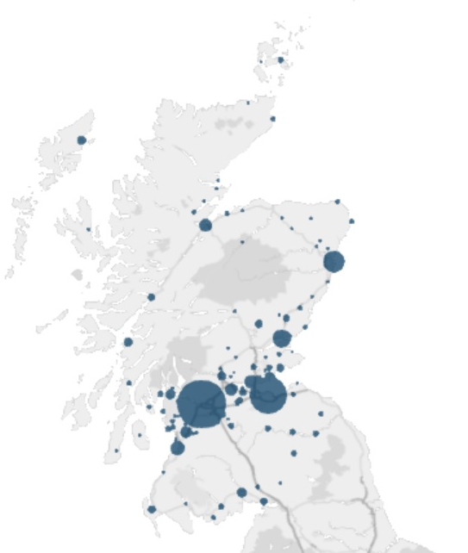
The Law Society of Scotland is the Professional Body AML Supervisor for Scottish solicitors, with a remit across c. 750 firms spread throughout Scotland. AML supervisory authority status has been ratified by Her Majesty's Treasury through Schedule 1 of the MLRs and is discharged through the use of the Solicitors (Scotland) Act 1980.
Our Regulatory Requirements
MLR r.46 sets out the Society’s primary duties and responsibilities in respect of AML supervision, including:
- adopting a risk-based approach to the exercise of its supervisory functions
- basing the frequency and intensity of its on-site and off-site supervision on the risk profile of our supervised population
- keeping a record in writing of the actions it has taken in the course of its supervision, and of its reasons for deciding not to act in a particular case
- taking effective measures to encourage its own sector to report breaches of the provisions of these Regulations to it

MLR r.49 sets out further duties upon the Society:
“Self-regulatory organisations must make arrangements to ensure that:
- their supervisory functions are exercised independently of any of their other functions which do not relate to disciplinary matters;
- sensitive information relating to the supervisory functions is appropriately handled within the organisation;
- they employ only persons with appropriate qualifications, integrity, and professional skills to carry out the supervisory functions;
- contravention of a relevant requirement by a relevant person they are responsible for supervising renders that person liable to effective, proportionate, and dissuasive disciplinary measures under their rules”.
“Self-regulatory organisations must:
- provide adequate resources to carry out the supervisory functions;
- appoint a person to monitor and manage the organisation’s compliance with its duties under these Regulations”
The Money Laundering and Terrorist Financing (Amendment) Regulations 2019 further prescribe that self-regulatory organisations such as the Society must also publish an annual report containing information regarding:
- measures taken by the self-regulatory organisation to encourage the reporting of actual or potential AML breaches
- the number of reports of actual or potential breaches received by that self-regulatory organisation
- the number and description of measures carried out by the self-regulatory organisation to monitor, and enforce, compliance by relevant persons with their obligations the MLRs, the Terrorism Act 2000 (TA) and the Proceeds of Crime Act 2002 (POCA)
This report is an updated version of our first, interim annual AML supervisory report published in February this year and highlights the work we have undertaken in fulfilling our supervisory obligations under the regulations.
The Society also expects the report to develop further in the coming years as our supervisory approach develops and matures, and more substantive information becomes available.
The Office for Professional Body Supervisors (‘OPBAS’)
In January 2018, new regulations gave rise to the set-up of OPBAS, with the aim of improving the consistency of AML supervision across the 22 Professional Body Supervisors (PBS). OPBAS sets out guidance and its expectations of PBSs in performance of their duties under the MLRs, in the form of the ‘OPBAS Sourcebook’ – which the Society must also adhere to.

2. Our AML supervisory work
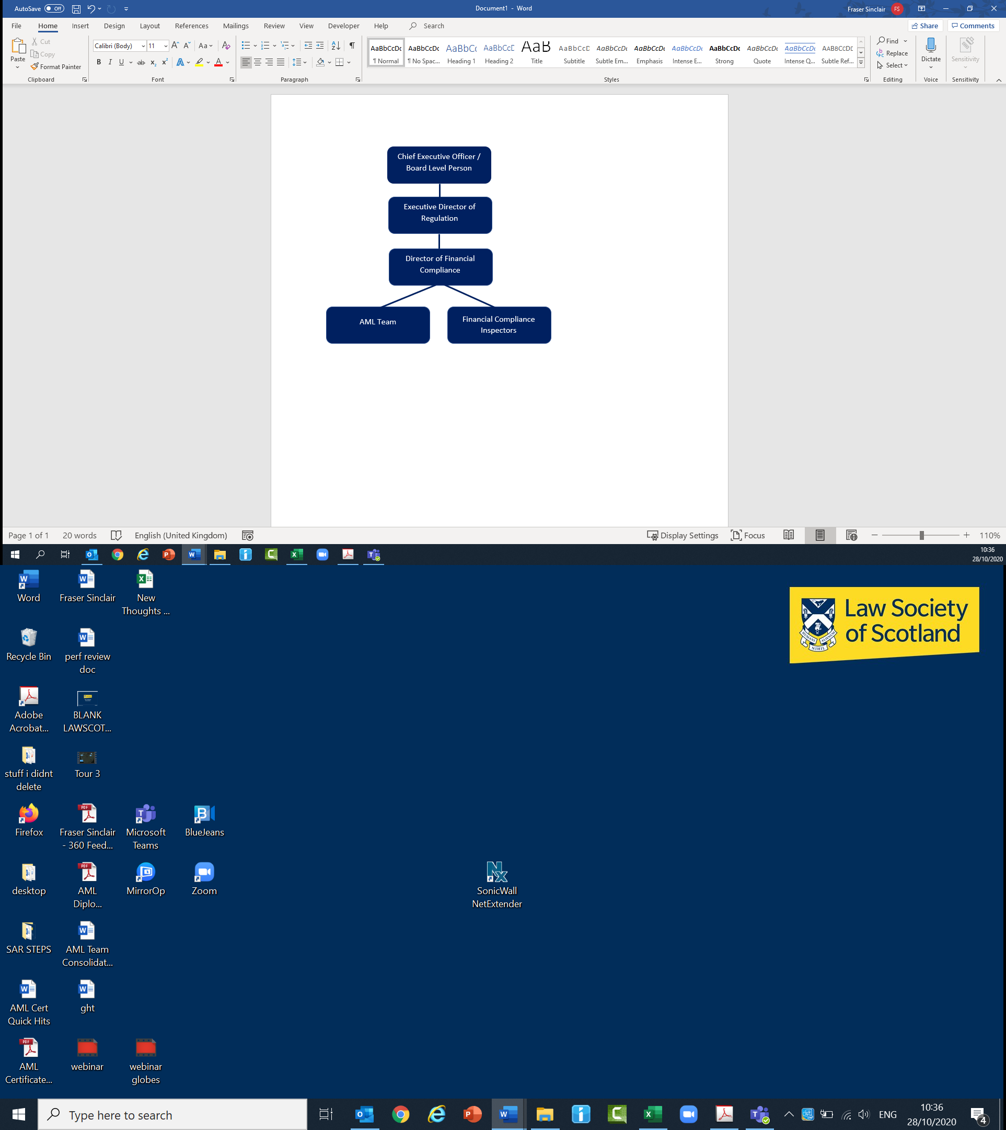
AML team - structure
The Society currently has a dedicated team of three AML experts consisting of the Head of AML and two managers, responsible for AML Supervisory and assurance work across the profession. We will shortly begin the process to recruit an additional two AML experts bringing headcount to five in total.
The AML team is embedded within (and supported by) the Society’s wider Financial Compliance and regulatory functions and prioritises assurance and other supervisory activity on a risk-based approach – in line with responsibilities under r.46.

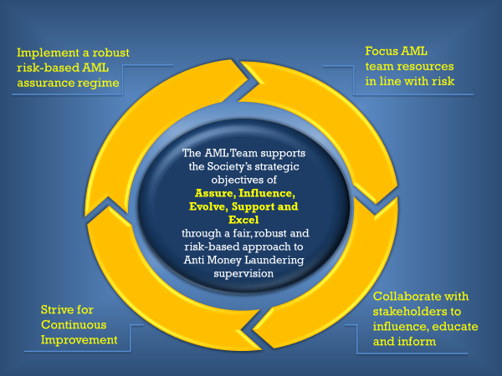
AML team mission statement and objectives

The AML Certificate and our risk-based approach to supervisory assurance
The Society’s AML Certificate is an annual compulsory questionnaire issued to in-scope firms, consisting of c. 50 questions relating to inherent AML risk factors. In line with the MLRs and the UK National Risk Assessment, it focuses on a firm’s inherent exposure to higher risk clients and areas of practice such as conveyancing, trust and company provision, along with geographic and delivery channel risk.
Once analysed, the data collected is used to build a risk profile of our supervised population, and can also allow us to understand specific risks, trends, or issues across individual firms.
This profiling mechanism allows the Society to satisfy requirements of r.46 – i.e., to adopt a risk-based approach by basing the frequency and intensity of our supervision according to the risk profile of our supervised population.
The Society also sets out our approach to risk-based supervision and associated outcomes in a Risk Appetite Statement published in February 2021
The Scottish Legal Profession – Inherent risks and risk profile
Through the analysis of our 2020/21 AML Certificate returns, we have built a risk profile of our supervised population – we believe that 280 firms represent an inherently lower risk of handling the proceeds of crime, 362 are at medium inherent risk and 54 pose an inherently higher risk given the type of business activities they undertake, the types of clients they hold and their geographical reach.
The analysis of AML certificate information also gives us the ability to identify specific risks within our supervised population.
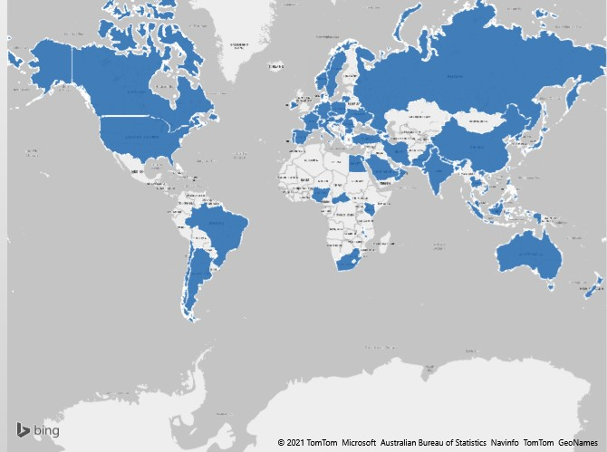
The geographic pictorial below, for example, shows international beneficial ownership information linked to conveyances for corporate clients, undertaken by Scottish solicitors.
We can also identify information linked to Trust and Company Service Provision (TCSP) or Politically Exposed Person (PEP) risk, for example:
<140 Conveyances linked to Politically Exposed Persons
64 Non-UK PEPs provided with a regulated service
>5000 Registered Offices provided
including ownership in China, Syria, Bermuda, Luxembourg and more.

AML Assurance
High Risk Reviews
(In accordance with the provisions of r.46) the AML team base the frequency and intensity of assurance work according to the risk profiles developed in the AML Certificate process.
Depending upon the circumstance and specific risks highlighted via the certificate, reviews can vary between full- firm inspections or reviews focused on specific files or areas of a firm’s business. We also perform ad-hoc reviews based on intelligence gathered from sources such as law enforcement and our reporting concerns helpline.
Full firm inspections test both the adequacy of a firm’s Policies, Controls and Procedures (PCPs) as set against fundamental regulatory requirements such as Customer Due Diligence (CDD), governance and internal controls, record keeping and training – moving forward we will also review PCPs in light of the recently revised Legal Sector Affinity Group AML Guidance, including its 36 ‘High Level AML Compliance Principles.’ The inspection process then goes on to review the effectiveness of such measures ‘on the ground’, by testing adherence to PCPs through sample review of higher risk file matters.
AML Certificate data allows us to sample effectively and efficiently, focusing on high-risk or other matters of interest from an AML perspective. This data forms the basis of file selection.
During the ongoing pandemic, all high-risk reviews have been successfully conducted remotely, using secure online tools and email encryption facilities – this will continue, in order to both ensure the safety of our employees and those of firms, along with reducing operational impacts on firms we inspect.

Medium Risk Reviews
Those firms deemed of medium inherent AML risk are also inspected on a cyclical basis, although this can be varied as required. Inspections are undertaken by the members of the wider financial compliance team. These inspections focus predominately on file-level AML compliance in the context of wider client accounting matters. The AML team works with the Financial Compliance team where issues are identified which may indicate higher AML risk. These can be reported to the AML team for further specialist investigation or input.

Assurance Statistics
High-risk:
18
High risk firm inspections and file reviews initiated since the first AML Certificate
From April 2020 to April 2021 we have conducted 18 high-risk assurance reviews – nine full firm inspections and nine file reviews.
The Society assesses compliance with requirements and relevant guidance across three key areas of a firm’s Policies, Controls and Procedures - namely Firm Level Risk Assessment, Governance structures and AML-related Policies and Procedures.
Across the nine full firm inspections undertaken we took varying levels of assurance relating to these areas of the firm’s AML control environments:
 | Firm Level Risk Assessments | Governance | AML Policies & Procedures
High assurance - There is a high level of assurance that the documentation reviewed is delivering compliance against the AML requirements, duties or responsibilities of the Practice Unit. The review has identified only limited scope for improvement in existing arrangements and as such it is not anticipated that significant further action is required to reduce the risk of non-compliance. | 4 firms | 5 firms
Reasonable assurance - There is a reasonable level of assurance the policy, control or procedure reviewed is delivering compliance against the AML requirements, duties or responsibilities of the Practice Unit. The review has identified some scope for improvement in existing arrangements to reduce the risk of non-compliance with these requirements | 5 firms | 2 firms | 5 firms
Limited assurance - There is a limited level of assurance that the policy, control or procedure reviewed is delivering compliance against the AML requirements, duties or responsibilities of the Practice Unit. The review has identified considerable scope for improvement in existing arrangements to reduce the risk of non-compliance with these requirements. |  | 2 firms | 4 firms

Four firms which were subject to a high-risk inspection process were referred to the Society’s AML Sub-Committee between April 2020 and April 2021, with no further action taken in these instances. The remaining five were subject to a programme of timed remediation, overseen by the AML team.
Medium Risk:
37 firms were subject to medium-risk inspections in the period April 2020 – April 2021
These reviews have led to a range of outcomes, from no further action required, to a tailored remediation plan being agreed with a follow-up re-inspection.
Assurance – General Observations
Anti-money laundering is not a zero-failure regime. The wider intention of our supervisory work is to help build a Scottish legal sector which is engaged with the issues around AML, which understands its risks and obligations and which therefore organically applies itself to the suppression of financial crime through adequate, effective and compliant policies, controls and procedures.

Through our AML assurance work and frequent engagement with the profession, the AML team have made some recurring observations on areas which require improvement in understanding and underlying compliance. These include:
- the requirement to undertake appropriate and ongoing due diligence on trust and company services provided to clients
- a general misunderstanding of the additional measures required in higher-risk situations – i.e. what contitutes effective ‘Enhanced Due Diligence’
- a lack of understanding around the definitions and the application of relevant Source of Funds/Source of Wealth checks – and in what circumstances these may be relevant
- a misunderstanding regarding Beneficial Ownership (including definitions, dilution issues and what is meant by ‘ultimate beneficial ownership’) and associated CDD requirements
- issues regarding contempareneous, comprehensive and compliant AML-related record-keeping and document management

3. AML training, competency and continual improvement

- to ensure the ongoing competence of the AML team and others involved in AML supervision, we continue to commission bespoke, specialist AML supervisory training via a third party AML expert training provider. We have previously invited other PBSs to participate in this training to share knowledge, expertise, and training, and play our part in ensuring consistency in professional body supervision across the legal sector.
- all members of our AML team are trained to International Compliance Association (ICA) Diploma standard, and regularly participate in continued professional development and training courses specifically related to AML
- to ensure continuous improvement standards, we have also engaged in a third party AML expert to review our AML supervisory assurance processes in light of recently released Financial Action Task Force (FATF) Guidance relating to risk-based supervision
4. Participation in national AML supervisory forums
The Society is an active member of key national AML supervisory forums, including the AML Supervisors forum (AMLSF), the Legal Sector AML Affinity Group (LSAG) and the Legal Sector Intelligence Sharing Working Group (ISEWG) (Chaired by the Society’s Director of Financial Compliance from July 2020).
This allows the Society to monitor legal sector AML developments, issues and trends, help promote joint working, collaboration and consistency in supervisory efforts cross-sector, and ensure gateways/contacts with key stakeholders such as HM Treasury, OPBAS, the National Crime Agency, HMRC and other Schedule 1 Professional Body Supervisors.
The Legal Sector ISEWG works to improve information sharing (regarding both AML risk trends and specific threats) between law enforcement and AML supervisors, so contributing to our risk-based approach.
We have recently led the efforts to develop and publish fully revised and updated legal sector AML guidance and are also active participants in relevant aspects of the Government’s Economic Crime Strategy.
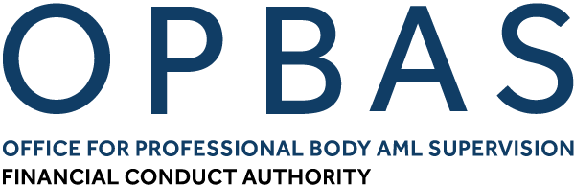






5. Reporting breaches and concerns

In response to our obligation under r.46 to take effective measures to encourage the sector to report breaches, the Society operates a reporting concerns’ hotline. This hotline allows anonymous concerns to be disclosed by any person (the public, solicitors or others working in the legal sector) via a phoneline and/or a dedicated webpage contact form. These channels are monitored and managed by the Society’s public communications team with agreed escalation routes to the Director of Financial Compliance in respect of any potential AML-related matters.
Reporting Concerns – key numbers – 2020/21
13 Reports Received by Director of Financial Compliance
5 Reports considered to be AML-related
4 Reports were utilised in our inspection programme

Concerns reported are all assessed for AML relevance. A number of reports received during 2020/21 were found to be unrelated to AML and where appropriate, reporters were advised by the Society to consider a complaint to the Scottish Legal Complaints Commission (SLCC).
Other official and unofficial channels for reporting breaches or concerns are also available and open to the profession.
We have, for example, included a specific section in the AML Certificate which asks respondents to share relevant information or intelligence which may help the Society mitigate AML risk within the sector.
Under r.46(5) obligations we ourselves also submit an average of 10 Suspicious Activity Reports (SARs) a year to the National Crime Agency, based on information gathered and suspicions arising from our inspection work and other activities.

6. Guiding the profession
The AML team also makes available relevant and appropriate support and guidance to help the profession achieve compliance with regulatory requirements.

To this end, the AML Team have undertaken a number of initiatives, including an extensive AML support section on our website.
The non-assurance work we undertake is important in the context of the wider support the Society offers its members and as illustrated here, can range from specific assistance to firms on AML matters, ad hoc queries, to webinars, conferences and national projects.

Case study: Collaboration with the NCA
The National Crime Agency has recently begun to implement a drive towards more digital engagement with external reporters and stakeholders.
We suggested to the UK FIU that it would be useful for SAR reporters had a step-by-step “demonstration” available to them to guide them through the online SARs reporting process. We have designed and produced a first-of-its-kind webinar tutorial with the aim of improving the quality of SARs submitted by Scottish solicitors (but also the wider regulated sector) so that they provide the correct information in the correct manner, in turn maximising value to law enforcement.
The webinar has been made available on our website alongside existing SAR Resources , and to other supervisors for their use.

Case Study: COVID Non-F2F AML Guidance
We quickly formulated and released new guidance for solicitors to help ensure compliance with CDD requirements in light of Covid-19 lockdown restrictions, addressing a major concern/blocker for the profession. The guidance can be accessed via this webpage

7. Moving forward
As a responsible AML supervisor we will continue to be sensitive to the challenging market dynamics presented as we move post-Covid – particularly to smaller firms, while remaining resolute and resilient in discharging our statutory obligations.

Central to balancing these challenges will be a continued, strong focus on our risk-based approach to supervisory assurance – using our resources wisely across areas of higher AML risk in our supervised population. To help achieve this objective (and to ensure the safety of our staff and those we work with) we will also continue to utlise secure technology to undertake fully remote inspections of firms and high risk transactions. We intend to use the newly published LSAG AML Guidance as a focal point and reference when undering our supervisory assurance work.

We also continue to strengthen our partnerships and co-operation with other supervisors and law enforcement agencies seeking formal information sharing protocols where possible. We will also seek to take forward a legislative solution to increase the level of fines which can be applied on response to AML breaches.

We continue to participate in the Government’s Economic Crime reform agenda and have also recently responded to two important UK Government consultations on the future of the UK Money Laundering framework and regime.

Other key pieces of work will include implementing the findings of the internal review of supevisory processes which is currently underway, along with a complete refresh of our r.17 sectoral risk assessment, driven by data collected through our AML Certificate process. These developments (in tandem with the risk appetite statement we released early this year) will drive a more focused, risk-based approach to our AML supervision, and in turn, compliance within our supervised population.

We look forward to working with the Scottish legal profession and our partners across the AML regulatory landscape to ensure the Scottish legal profession continues to be a hostile environment in which to launder the proceeds of crime.

